Happyland Band

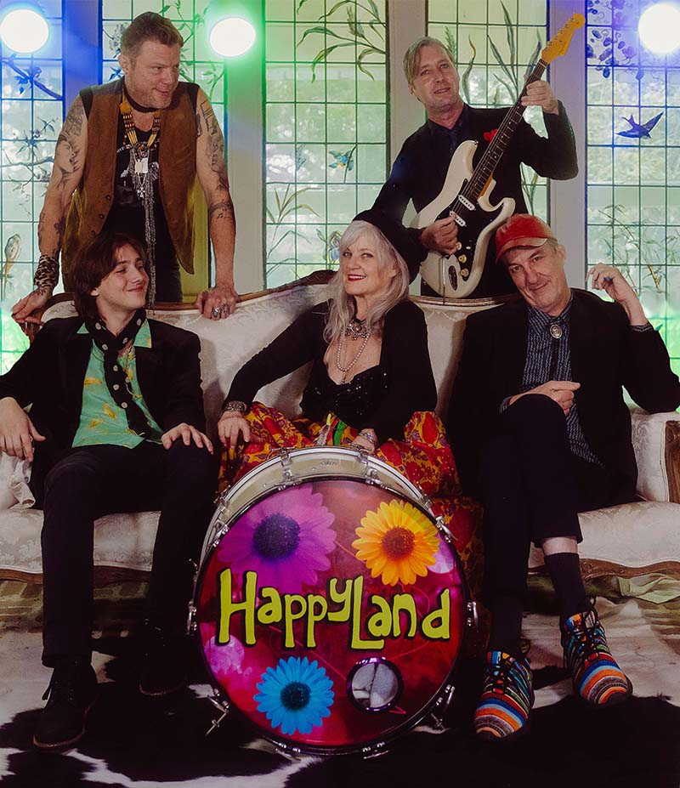

In crazy and heavy times, we all need to smile. We all need to spend some time in Happyland, Austin's new feel-good band, formed by friends through mutual admiration and dinner parties. Fronted by four singer-songwriters like the classic harmony and multi-singer bands Eagles and CSN&Y. First, there's legendary, award winning artist and singer-songwriter Kimmie Rhodes, who has released 19 albums and whose songs have been covered by everyone from Willie Nelson to Peter Frampton to Emmylou Harris. Next is Kimmie's son, songwriter, multi-instrumentalist, and producer Gabriel Rhodes, who has worked with Willie Nelson, Billy Joe Shaver, Jimmie Dale Gilmore, and countless others. Songwriter and recording artist Shawn Pander's beautiful, soulful songs and voice have made him a "must see" artist and gotten him and his music featured on FEARLESS MUSIC TV (FOX) and the Dr. Phil Show. Happyland also features drummer John Chipman (Band of Heathens, Pat Byrne), bass player, Harmoni Kelley (Kenny Chesney), and a third generation of Rhodes, Keyboard player Louis Rhodes.

Check out Happyland's debut single, "Happyland" available everywhere you stream.

For more information contact – Nancy Coplin – nancycoplin@gmail.com

